World Association for Dynamic Psychiatry www.wadpinternational.com

20th WADP congress / XXXIII International Symposium of the German Academy
for Psychoanalysis (DAP) e.V., 16.04.2024 to 20.04.2024, Marrakech, Morocco
"Social Challenges - Shared Responsibility in Psychiatry and Psychotherapy”
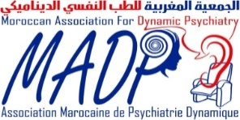
in cooperation with and organized by
Abstract template for Fellowship Application
to be sent to Email: DAPBerlin@t-online.de, Subject heading: Application for fellowship
☐ Male / ☐ Female / ☐ Other:
Name: First Name: Title / Position:
Institution: Medical School:
Country:
Email address:
Presentation title:
Abstract text up to 800 words in English (Arial 11) :

